- Purpose
  - The purpose of this document is to describe the procedure for assembling the Disk Engagement Plates for the Disk units.
- Scope
  - This SOP applies to all equipment assembly team members. The process applies to the following ID’s:
EP50323EQS0600BE1200 – 26” Disc Head Assembly
EP50324EQS0600BE1200 – 28” Disc Head Assembly
EP50325EQS0600BE1200 – 32” Disc Head Assembly
- Responsibilities
  - The operations manager/supervisor is responsible for enforcing this SOP.
- Materials
  - The proper materials needed for this process are listed on the machine work order.
- Definitions

- Proceduref
  - Take a Disk Engagement Plate (E28589) and attach it to a Disk Alignment Coupler (E28588) using 6 Flat Head Screws (E29391). Use blue Loctite on the screws. Ensure proper orientation. Torque bolts to a minimum of 6.3 ft-lbs. Mark the bolt head for orientation with a paint marker.

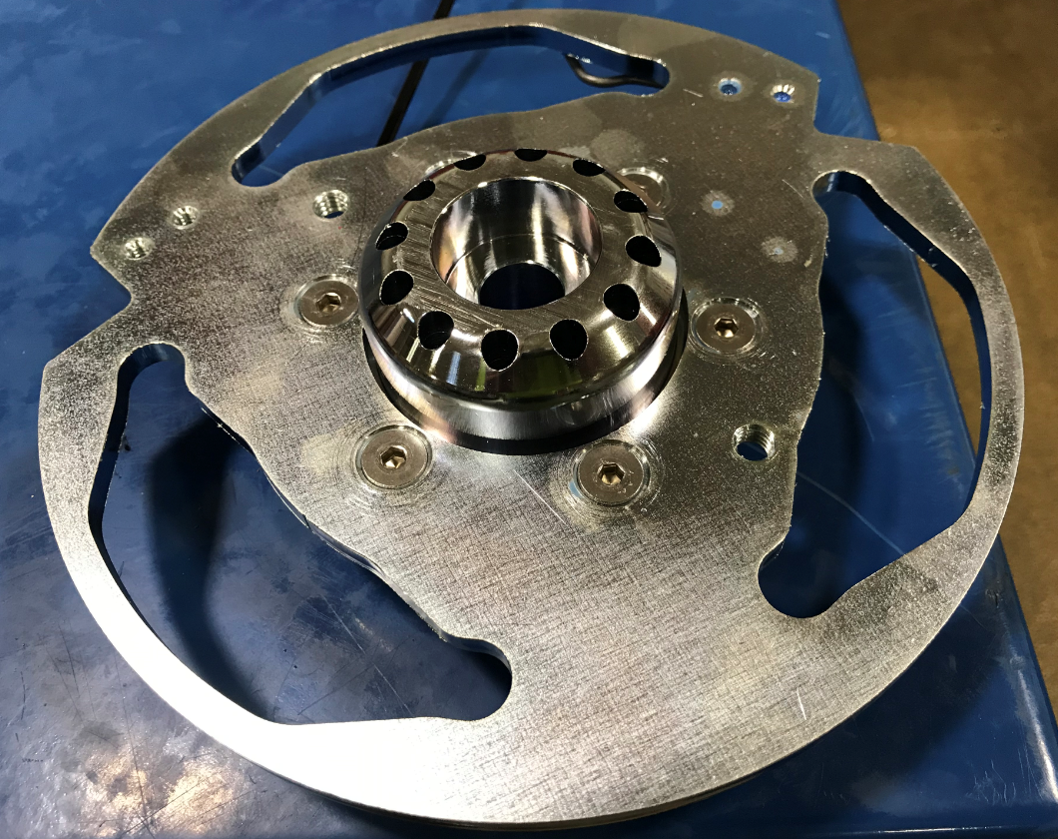
  - Flip the assembly over and fasten a disk lock spring (E29518) by sandwiching it between a spring clip support (E29515) and a spring retaining bracket (E29519). Attach it with 2 screws (E29390). Use blue Loctite on the screws. The spring should still be able to float.
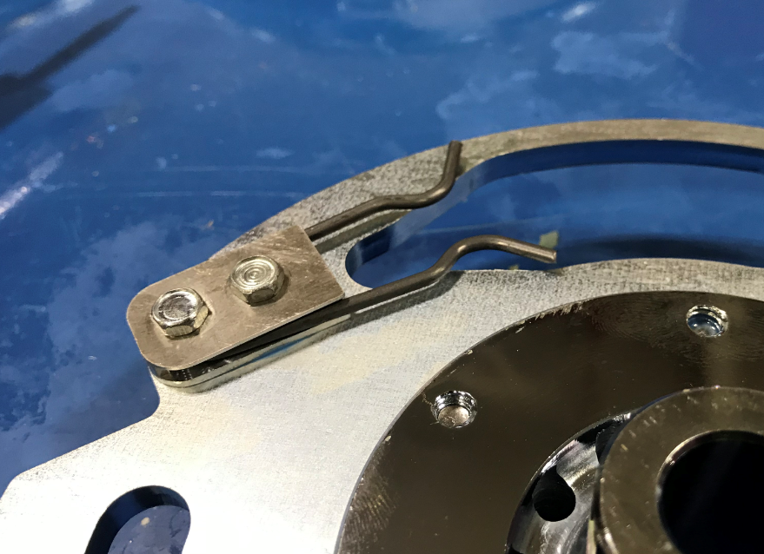
  - Make a 2nd assembly as a mirror to the first by changing the location of the lock spring to the other side of the slot. They should be a mirrored set. Ensure all components are oriented properly.

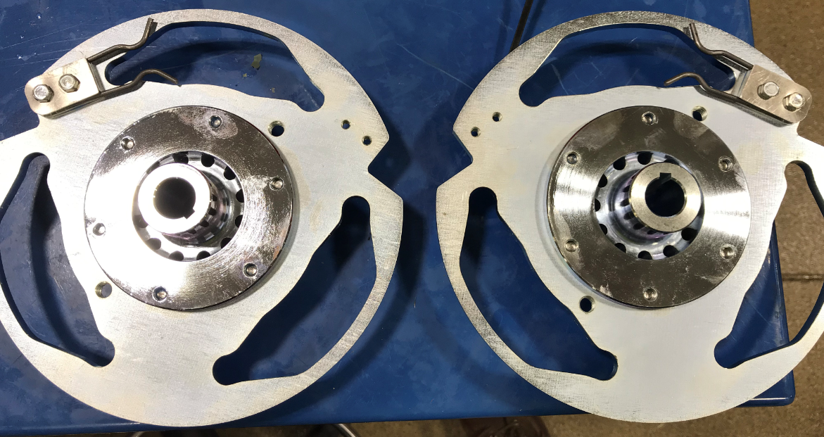

- References (optional section as needed)

- Training Guide

Functional Training Groups Requiring Training
Equipment Assembly Group

- SOP Change Control

Date of Change | Reason for Change
Rev 01 | This is the first version of the S.O.P. hence there are no revisions to this document.
Rev 02 - 8/13/2021 | Added QC Check and torque check.
Rev 03 - 4/1/2025 | Reviewed and updated

Approvals

Submitter/Author Approval:__________________________________ Date:______________________

Management Approval:______________________________________ Date:______________________

QAU Approval:_____________________________________________ Date:______________________

